Person County
School Recycling Grant Program

Apply for your school to receive funds from the first
Person County School Recycling Grant program!

In Person County we understand that recycling is important for sustaining our community for the future. What better way to inspire more people to recycle than by teaching our kids!

All K-12 schools located in Person County are encouraged to apply. We have a total of $14,490 to award to selected schools to implement recycling programs. The grant amounts will be determined by the number of awards given and the overall proposal scores. Proposals can receive up to 100 points based on
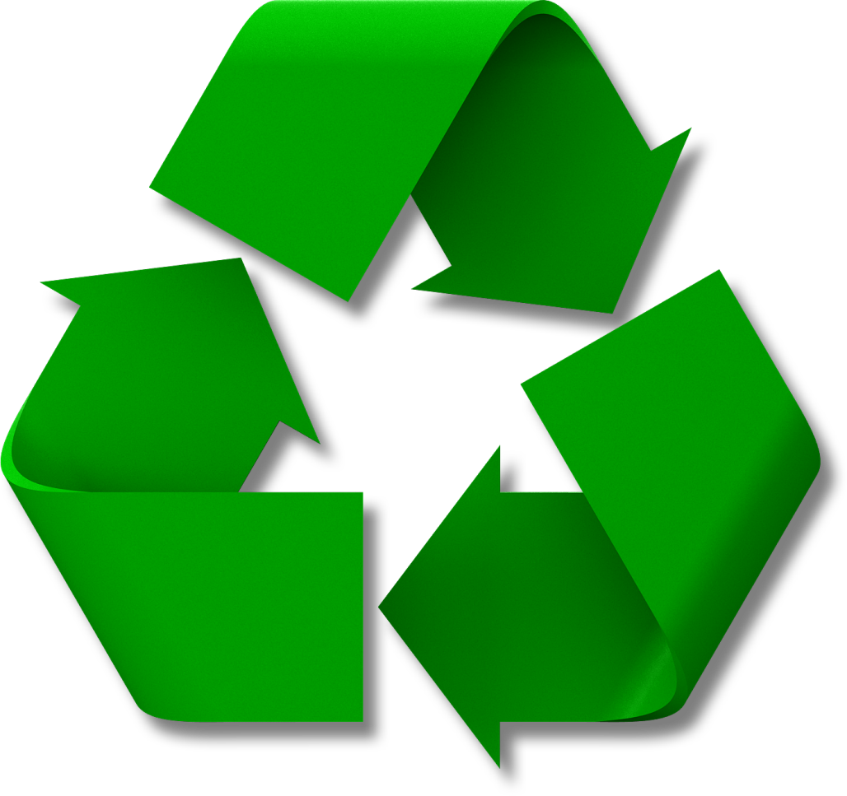
- Project Impact
- Planning, Organization, and Sustainability
- Cost
- Education and Outreach

Proposals demonstrating matching funds will receive five (5) bonus points.

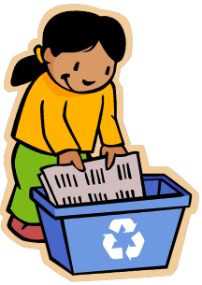
Proposal applications will be released electronically on the Person Industries page of the County website at www.personcounty.net and emailed directly to schools on August 12, 2013. The final date to submit your proposal is September 23, 2013. Awards will be announced on Monday, October 14, 2013.

Questions? Contact Becky Clayton at
336.599.7571 ext. 2825 or bclayton@personcounty.net

